TASKS
- Setting the margins (2x2x2x2).
- Page numbering (bottom of page, centring) .
- Headings (task…).
- Page break, section breakes (a page break for the chapters).
- Automatic table of contents (Heading 1, Heading 2).
- Automatic table of figures (centring of drawings and captions).
- Page orientation (landscape for Table 1, section break).
- Adding a watermark (task).
- Save the document in PDF format.
- Adding a password securing a document (task).
BYDGOSZCZ

TABLE OF CONTENTS

TABLE OF FIGURES

INTRODUCTION

Lorem Ipsum is text that is used as an example filler in the printing industry. It was first used in the 15th century by an unknown printer to fill in a sample book with text. Five centuries later, it began to be used in the electronics industry, while remaining virtually unchanged. It became popular in the 1960s with the publication of Letraset worksheets containing excerpts from Lorem Ipsum , and more recently with the various versions of Lorem Ipsum software designed to produce prints on self-like computers such as Aldus PageMaker .

A well-known thesis states that the user may be distracted by the understandable content of the page when he wants to see its appearance. One of the strengths of using Lorem Ipsum is that it has many different "combinations" of sentences, words and paragraphs as opposed to the usual "text, text, text" making it look "too legible" in Polish. Many webmasters and designers use Lorem Ipsum as their default text model, and typing ' lorem ipsum ' into an online search engine will find a great many pages that are still under construction. Many versions of the text have evolved and changed over the years, sometimes by accident, sometimes special (humorous inserts etc ).

Contrary to popular belief, Lorem Ipsum is not just random text. It has its roots in classical Latin literature from 45 BC, over 2,000 years ago! Richard McClintock , a professor of Latin at Hampden- Sydney University in Virginia, took a closer look at one of the most obscure words in Lorem Ipsum - consectetur - and after much research he found an undeniable source: Lorem Ipsum comes from passages (1.10.32 and 1.10.33) " de Finibu s Bonorum et Malorum ", or" On the Border between Good and Evil, "written just in 45 BC by Cicero . It is a dissertation on ethics very popular during the Renaissance. The first poem by Lorem Ipsum , " Lorem ipsum dolor sit amet ..." is from section 1.10.32.

The standard Lorem Ipsum block , in use since the 15th century, is reproduced below for those interested. Excerpts 1.10.32 and 1.10.33 of Cicero's "de Finibus Bonorum et Malorum " are reproduced in the exact original form, along with the English translation of H. Rackham from 1914.

CHAPTER 1

Lorem Ipsum is text that is used as an example filler in the printing industry. It was first used in the 15th century by an unknown printer to fill in a sample book with text. Five centuries later, it began to be used in the electronics industry, while remaining virtually unchanged. It became popular in the 1960s with the publication of Letraset worksheets containing excerpts from Lorem Ipsum, and more recently with the various versions of Lorem Ipsum software designed to produce prints on self-like computers such as Aldus PageMaker.

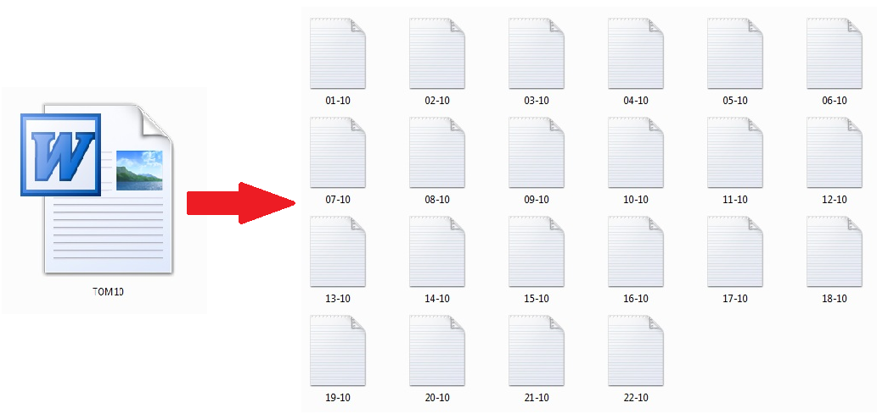

A well-known thesis states that the user may be distracted by the understandable content of the page when he wants to see its appearance. One of the strengths of using Lorem Ipsum is that it has many different "combinations" of sentences, words and paragraphs as opposed to the usual "text, text, text" making it look "too legible" in Polish. Many webmasters and designers use Lorem Ipsum as their default text model, and typing ' lorem ipsum ' into an online search engine will find a large number of pages that are still under construction. Many versions of the text have evolved and changed over the years, sometimes by accident, sometimes special (humorous inserts etc ).

Contrary to popular belief, Lorem Ipsum is not just random text. It has its roots in classical Latin literature from 45 BC, over 2,000 years ago! Richard McClintock , a professor of Latin at the University of Hampden- Sydney, Virginia, took a closer look at one of the most obscure words in Lorem Ipsum - consectetur - and after much research he found an undeniable source: Lorem Ipsum comes from passages (1.10.32 and 1.10.33) " de Finibus Bonorum et Malorum ", or" On the Border between Good and Evil, "written just in 45 BC by Cicher she. It is a dissertation on ethics very popular during the Renaissance. The first poem by Lorem Ipsum , " Lorem ipsum dolor sit amet ..." is from section 1.10.32.

The standard Lorem Ipsum block , in use since the 15th century, is reproduced below for those interested. Excerpts 1.10.32 and 1.10.33 of Cicero's "de Finibus Bonorum et Malorum " are reproduced in the exact original form, along with the English translation of H. Rackham from 1914.
Table 1
No. | Volume number | Number of articles | Number of pages | Number of words in the volume | Number of nicks in the volume without spaces
1 | 1 | 7 | 168 | 56 642 | 389 916
2 | 2 | 15 | 123 | 32 692 | 224 282
3 | 3 | 17 | 220 | 59 872 | 396 895
4 | 4 | 25 | 230 | 72 246 | 489 829
5 | 5 | 18 | 167 | 47 979 | 329 788
6 | 7 | 9 | 91 | 22 733 | 153 587
7 | 8 | 22 | 195 | 59 787 | 414 125
8 | 10 | 22 | 231 | 60 527 | 408 110
9 | 12 | 7 | 115 | 42 387 | 277 686
10 | 13 | 21 | 177 | 50 734 | 350 003
Suma |  | 163 | 1 717 | 505 599 | 3 434 221

SUBSECTION 1.1

Lorem ipsum is a text used as an example filler in the printing industry. It was for the first time in the 15th century by an unknown printer to fill in the text of a test book. Five centuries later, it began to be used in the electronic industry, which is practically unchanged. It was popularized in the 60s of the twentieth century, together with the publication of the letraset sheets, containing the lorem ipsum fragments, and lastly with the various versions of lorem ipsum, software for the personalized personalization of the drivers.

SUBSECTION 1.2

The common those claims that the user may be distracted by the understanding of the content of the site when you want to see its look. One of the strengths of the use of lorem ipsum is that it has many different "combinations" of sentences, words, and paragraphs, unlike the ordinary: "text, text, text" makes it "so like" polish look. Many webmasters and designers use lorem ipsum as the default text model and entering in the internet search engine will find very many pages that are still under construction. In iele version of the text it has evolved varied over the years, sometimes for accident, sometimes specially (humor and the like).

CHAPTER 2

Lorem Ipsum is text that is used as an example filler in the printing industry. It was first used in the 15th century by an unknown printer to fill in a sample book with text. Five centuries later, it began to be used in the electronics industry, while remaining virtually unchanged. It became popular in the 1960s with the publication of Letraset sheets containing excerpts from Lorem Ipsum , and more recently with the various versions of Lorem Ipsum software designed for making prints on personal computers, such as Aldus PageMaker .
A well-known thesis states that the user may be distracted by the understandable content of the page when he wants to see its appearance. One of the strengths of using Lorem Ipsum is that it has many different "combinations" of sentences, words and paragraphs as opposed to the usual "text, text, text" making it look "too legible" in Polish. Many webmasters and designers use Lorem Ipsum as their default text model, and typing ' lorem ipsum ' into an online search engine will find many pages that are still under construction. Many versions of the text have evolved and changed over the years, sometimes by accident, sometimes specifically (humorous inserts etc ).

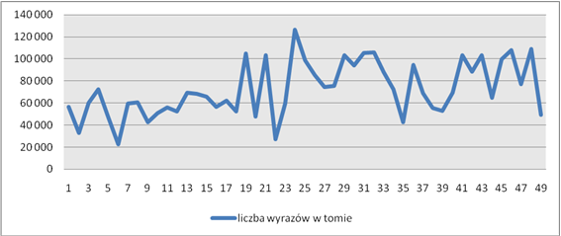

Contrary to popular belief, Lorem Ipsum is not just random text. It has its roots in classical Latin literature from 45 BC, over 2,000 years ago! Richard McClintock , a professor of Latin at the University of Hampden- Sydney, Virginia, took a closer look at one of the most obscure words in Lorem Ipsum - consectetur - and after much research he found an undeniable source: Lorem Ipsum comes from passages (1.10.32 and 1.10.33) " de Finibu s Bonorum et Malorum ", or" On the Border between Good and Evil ", written just in 45 BC by Cicero. It is a dissertation on ethics very popular during the Renaissance. The first poem by Lorem Ipsum, " Lorem ipsum dolor sit amet ..." is from section 1.10.32.
The standard Lorem Ipsum block, in use since the 15th century, is reproduced below for those interested. Excerpts 1.10.32 and 1.10.33 of Cicero's "de Finibus Bonorum et Malorum " are reproduced in the exact original form, along with the English translation of H. Rackham from 1914.

SUMMARY

Contrary to popular belief, Lorem Ipsum is not just random text. It has its roots in classical Latin literature from 45 BC, over 2,000 years ago! Richard McClintock , a professor of Latin at Hampden- Sydney University in Virginia, took a closer look at one of the most obscure words in Lorem Ipsum - consectetur - and after much research he found an undeniable source: Lorem Ipsum comes from passages (1.10.32 and 1.10.33) " de Finibu s Bonorum et Malorum ", or" On the Border between Good and Evil, "written just in 45 BC by Cicero she. It is a dissertation on ethics very popular during the Renaissance. Lorem Ipsum's first poem, " Lorem ipsum dolor sit amet ..." is from section 1.10.32.
The standard Lorem Ipsum block, in use since the 15th century, is reproduced below for those interested. Excerpts 1.10.32 and 1.10.33 of Cicero's "de Finibus Bonorum et Malorum " are reproduced in the exact original form, along with the English translation of H. Rackham from 1914.

